

International Journal of Agricultural Research and Multidisciplinary Research Trends
Peer Reviewed | Open Access | Indexed Journal
Website: www.ijarmrtresearchjournal.com
E-ISSN: XXXX-XXXX | P-ISSN: XXXX-XXXX

Write Article Complete Title Here

¹Author Name, ²Author Name, ³Author Name and ⁴Author Name
¹Post, Department, Present University/College Working/Studying Palace, State and country.
²Post, Department, Present University/College Working/Studying Palace, State and country.
³Post, Department, Present University/College Working/Studying Palace, State and country.
⁴Post, Department, Present University/College Working/Studying Palace, State and country.

Corresponding Author: Main Author Name
Received: Day/Month/Year, Accepted: Day/Month/Year, Published: Day/Month/Year

Abstract
Write a concise summary of the research study in 150–300 words in a single paragraph. Include purpose, methodology, key findings, conclusion, and future scope.
Keywords
Keywords1, Keywords2, Keywords3, Keywords4, Keywords5.

Introduction
Provide a brief background, objectives, significance, and recent references related to the topic.

Materials and Methods
Describe research design, sample size, tools, data collection process, and statistical methods used.

Results
Present results clearly with tables, charts, figures, and observations.

Body paragraphs
Provide a concise background, objectives, and significance of the study ^{[1]}. Use A4 page size (210 × 297 mm), set margins to 10 mm on all sides, and format the manuscript in two-column layout with standard font settings.

Body paragraphs
The manuscript should include a clear background, objectives, and significance of the study ^{[1]}. It must explain the research problem, existing gaps, and purpose of the study in a concise manner. The content should be formatted on A4 size (210 × 297 mm) with 10 mm margins on all sides in a two-column layout using standard font settings.

Proper alignment and formatting must be maintained throughout the manuscript to ensure consistency with journal publication standards

Mathematical expressions may be added where required, for example:

PV=nRT

where P is pressure, V is volume, n is moles, R is gas constant, and T is temperature.

Figures and Tables
All figures and tables must be high-quality (300 dpi) and submitted in JPG/JPEG format. They should be placed immediately after first citation in the text and numbered sequentially (Figure 1, Table 1, etc.) with proper captions for clarity and consistency.

Place the title and table number above each table.

Table 1: Description (Size 9, Times New Roman)

Margin | A4 Paper | US Letter Paper
Left | 18.5 mm | 14.5 mm (0.58 in)
Right | 18mm | 8 m (0.51 in)

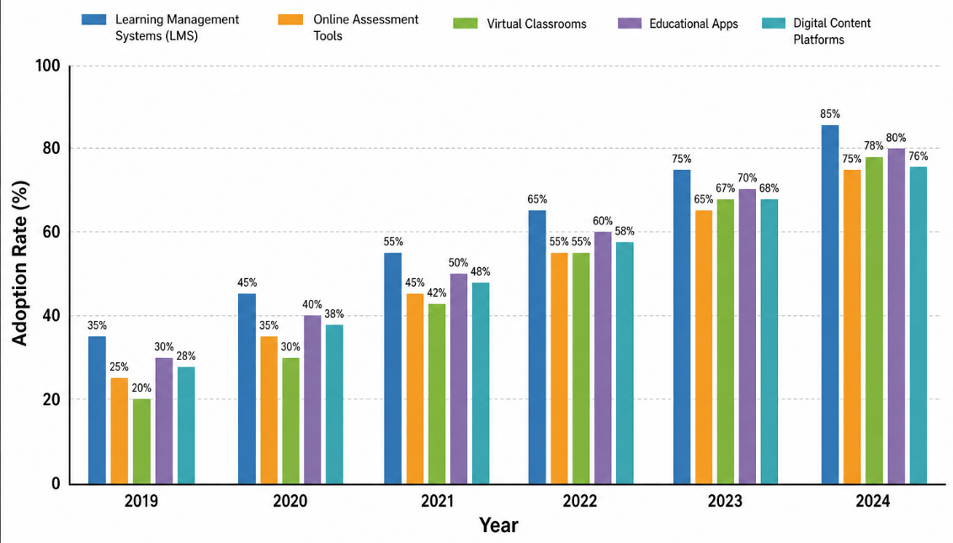

Fig 1: Description (Size 9, Times New Roman)

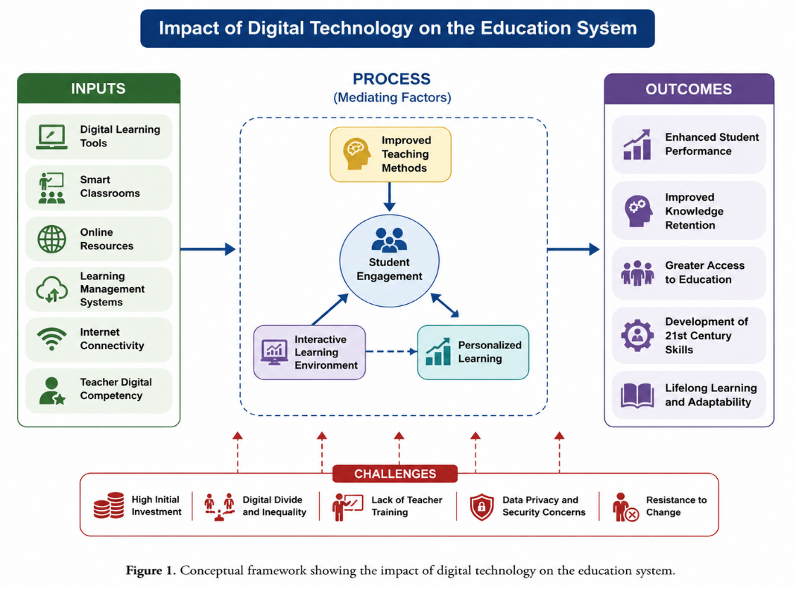

Chart 1: Description (Size 9, Times New Roman)

Discussion
Interpret the results and compare findings with previous studies.

Conclusion
Summarize major outcomes, practical implications, and future scope.

Other recommendations
Authors should ensure that both columns on the final page are evenly balanced. In MS Word, this can be adjusted using Insert → Break → Continuous.

Acknowledgment
(Optional) Mention support, institution, or contributors.
Funding
No external funding received.

Ethical Approval
Approved by concerned ethics committee, if applicable.

Conflict of Interest
The authors declare no conflict of interest.

Data Availability
Data available from corresponding author on request.

Appendix
(Optional) Include supplementary data, formulas, or additional material.
References (Vancouver Style)
- Author Name. Title of the Article. Journal Name. Year Month [cited Year Month Day];Volume(Issue):Page Number. (Vancouver Style)
- Author Name, “Title of the Article,” Journal Name, Volume(Issue), pp. Page Number, Year. (Journal Citation Style)
- Author Name. “Title of the Article.” Journal Name, vol. Volume, no. Issue, Year, pp. Page Number. (MLA Style)
- Author Name. “Title of the Article.” Journal Name, vol. Volume, no. Issue, Year, pp. Page Number. (MLA 9th Edition)
- Author Name. “Title of Chapter,” in Book Name, Editor Name (eds.), Publisher Name, Place, Year. (Book Chapter Style)
- Author Name. Book Name. Publisher Name, Place, Year. (Book Style)
- Author Name, “Title of Paper,” in Proceedings of Conference Name, pp. Page Number, Year. (Conference Style)
- Author, A. A. (Year, Month). Title of the article. Journal Name, Volume(Issue), Page Number(s). Retrieved Month Day, Year. (APA Style)
- A. Author Name, “Title of the article,” Journal Name, vol. Volume, no. Issue, pp. Page Number(s), Month Year. (IEEE Style)
- Author Name. Title of the article. Journal Name. Year;Volume(Issue):Page Number(s). (AMA Style)
- Author Name. “Title of Web Page,” Website Name, para. number, Year. [Online]. Available: Website Link. [Accessed: Date]. (Internet Style)
- Author Name. Title of the Article. Journal Name Year, Volume (Issue), Page Number(s). (ACS Style)
- Autho Author Name. “Title of the Article.” Journal Name Volume, no. Issue (Year): Page Number(s). (Chicago Style)
- Author Name Year, ‘Title of the article’, Journal Name, vol. Volume, no. Issue, pp. Page Number(s). (Harvard Style)
- Author Name. “Title of Report,” Technical Report Name, Institute Name, Place, Year. (Technical Report Style)
- Author Name. ‘Title of the Article’, Journal Name, vol. Volume, no. Issue, Year, pp. Page Number. (Oxford Style)
- Author Name. Title of the article. Journal Name. Year;Volume(Issue):Page Number(s). (Vancouver Style)

